**A**

**PROJECT REPORT**

**ON**

“Recognition of Dominant Colors in a Picture”

**Submitted as partial fulfillment for the award of**

**BACHELOR OF TECHNOLOGY DEGREE**

Session 2023-24

**In**

**Computer Science and Engineering**

## Submitted by:

Sreethu K Binu (2100970100117)

**Under the supervision of :**

**Dr. Aditya Dev Mishra**

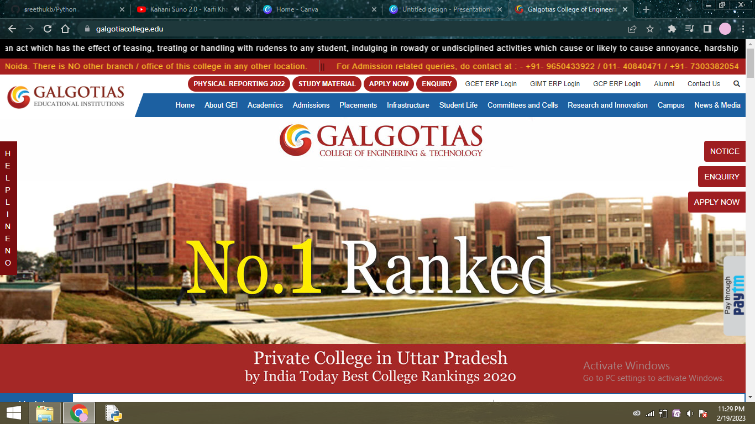

## DEPARTMENT OF COMPUTER SCIENCE AND ENGINEERING

## GALGOTIAS COLLEGE OF ENGINEERING AND TECHNOLGY

GREATER NOIDA



AFFILIATED TO

Dr. A.P.J. ABDUL KALAM TECHNICAL UNIVERSITY

LUCKNOW

# CERTIFICATE

This is to certify that the mini-project report entitled “**Recognition of Dominant Colors in a Picture**” submitted by Ms. **SREETHU K BINU (2100970100117)** to Galgotias College of Engineering & Technology, Greater Noida, Utter Pradesh, affiliated to Dr. A.P.J. Abdul Kalam Technical University, Lucknow, Uttar Pradesh in partial fulfillment for the award of Degree of Bachelor of Technology in Computer science & Engineering is a bonafide record of the project work carried out by them under my supervision during the academic year 2023-2024.

**Dr. Aditya Dev Mishra Dr.Vishnu Sharma**

**Dept. of CSE Professor and Head**

**Dept. of CSE**

# ACKNOWLEDGEMENT

I have made efforts in this project. However, it would not have been possible without the kind support and help of many individuals and team members. I want to extend my sincere thanks to all of them.

I am extremely indebted to **Dr. Vishnu Sharma**, HOD, Department of Computer Science and Engineering, GCET, and **Dr. Aditya Dev Mishra**, Project Coordinator, Department of Computer Science and Engineering, GCET for their valuable suggestions and constant support throughout my project tenure. I would also like to express our sincere thanks to all faculty and staff members of the Department of Computer Science and Engineering, GCET for their support in completing this project on time.

I also express gratitude towards our parents for their kind co-operation and encouragement which helped us in the completion of this project. My thanks and appreciation also go to my friends in developing the project and all the people who have willingly helped me out with their abilities.

SREETHU K BINU

2100970100117

**ABSTRACT**

The ability to identify the most dominant colors in images through the process of extraction and analysis holds immense value. The project aims to develop an efficient method for this purpose that utilizes the K-Means clustering algorithm. K-Means clustering, a popular unsupervised machine learning technique, enables the segmentation of an image into clusters, where each cluster represents a dominant color. By leveraging the power of K-Means clustering, we can automate the process of identifying prominent color palettes without the need for manual selection or analysis. This project encompasses image preprocessing, K-means clustering, color frequency analysis, visualization, and parameter optimization, resulting in a tool that provides insights into the prevalence of dominant colors. This tool enables users to make informed decisions based on image aesthetics, making it an effective and practical solution for using color analysis in visual content. Our project is designed to empower graphic designers and data scientists alike with the tools and knowledge they need to achieve their goals.

**TABLE OF CONTENTS**

|  |  |  |
| --- | --- | --- |
| **S. No.** | **CONTENT** | **PAGE NO.** |
|  | **TITLE**  **CERTIFICATE**  **ACKNOWLEDGEMENT**  **ABSTRACT**  **CONTENTS** | **i**  **ii**  **iii**  **iv**  **v** |
| 1. | **INTRODUCTION** | 1 |
| 2. | **LITERATURE REVIEW** | 2 |
| 3. | **METHODOLOGY**  3.1. IMAGE PREPROCESSING  3.2. K-MEANS CLUSTERING ALGORITHM | 4 |
| 4. | **SOURCE CODE AND ITS EXPLANATION** | 6 |
| 5. | **RESULT AND DEMONSTRATION** | 10 |
| 6. | **CONCLUSION** | 12 |
| 7. | **REFERENCES** | 13 |

**INTRODUCTION**

The process of image processing and color analysis involves identifying the predominant colors present in an image, which has immense significance in different fields. To achieve this, our project aims to leverage the K-means clustering algorithm, a potent technique that can effectively unveil the dominant color palette encapsulated within an image.

The K-means algorithm is a widely used unsupervised learning technique that plays a crucial role in data clustering. It offers a robust means to divide a set of data points into distinct groups based on their similarity, to identify underlying patterns or structures in the data. Leveraging its versatility, we can use the K-means algorithm to extract and identify the prevailing colors present in an image, which can be a useful tool in efficient color recognition and analysis. By applying this technique, we can effectively reduce the complexity of the image data and gain insights into the distribution of colors in the image. This, in turn, can be useful in a wide range of applications, from image processing and computer vision to data visualization and analysis.

Effective implementation and seamless integration of various components are crucial for the success of any information system. System analysis and design play a significant role in ensuring that these components work together seamlessly. The process of system analysis and design involves identifying business problems, analyzing the requirements of information systems, and designing solutions by applying various analysis and design techniques. Through this process, organizations can create efficient and effective information systems that meet their unique business needs and help them achieve their strategic objectives.

Through the utilization of K-means clustering, this project aims to provide a streamlined method for identifying and quantifying dominant colors, ultimately contributing to enhanced image interpretation and manipulation.

**LITERATURE REVIEW**

**Recognition of Dominant Colors in a Picture using K-means Clustering**

The identification and extraction of dominant colors in images using the K-means algorithm have been the subject of extensive research in the field of image processing and computer vision. Various studies have explored different aspects, methodologies, and applications of this technique.

*1. K-means Clustering for Color Analysis:* Numerous research works have highlighted the efficacy of K-means clustering in segmenting and extracting dominant colors from images. Authors such as J. Wang et al. (2014) demonstrated the application of K-means for color quantization, effectively reducing the color palette while preserving visual quality in compressed images.

*2. Color Space and Representation:* The choice of color space significantly impacts the results of color recognition. Studies by M. H. Abdelaziz et al. (2017) explored different color spaces, including RGB, HSV, and Lab, emphasizing their influence on clustering performance and the representation of dominant colors in images.

*3. Optimal ‘K’ Determination:* Determining the appropriate number of clusters (‘K’) remains a critical aspect. Techniques such as the elbow method, silhouette analysis, and advancements proposed by A. Singh et al. (2019) introduced novel approaches to automatically determine the optimal ‘K’ for more accurate identification of dominant colors.

*4. Applications and Use Cases:* The application of dominant color recognition spans various domains. T. Lu et al. (2018) investigated the use of K-means-based dominant color extraction for content-based image retrieval, showcasing its effectiveness in retrieving visually similar images.

*5. Enhancements and Algorithmic Improvements:* Researchers like G. Jiang et al. (2020) have proposed enhancements to traditional K-means, incorporating optimizations like mini-batch K-means or parallel processing, aimed at improving the efficiency of color recognition in large-scale image datasets.

*6. Challenges and Future Directions:* Several studies highlighted challenges, including sensitivity to initialization, computational complexity, and the impact of noise on color clustering. Future research directions involve exploring deep learning-based approaches for more robust color feature extraction and advancing clustering algorithms’ performance in complex image datasets.

The literature review provides an in-depth analysis of the K-means algorithm and its importance in identifying dominant colors in images. It delves into various methodologies employed by researchers in this field, highlighting their strengths and limitations. The review also discusses the challenges faced in color recognition and analysis in images, including issues related to noise, lighting, and image quality. Additionally, the potential applications of this algorithm in various fields, such as healthcare, robotics, and surveillance are explored. The review concludes by emphasizing the need for continued research in this area, to overcome the limitations and explore advanced techniques that can enhance color recognition and analysis in images.

**METHODOLOGY**

**IMAGE PREPROCESSING**

Image preprocessing is crucial for the effective analysis and recognition of dominant colors using the K-means clustering algorithm. It involves operations and techniques to enhance image quality, reduce noise, and improve color extraction accuracy.

**Importance of Image Preprocessing:**

1. **Noise Reduction:** Images often contain noise, which can interfere with color analysis. Preprocessing techniques like Gaussian blurring, median filtering, or denoising algorithms help in reducing noise, ensuring a cleaner representation of colors.
2. **Normalization and Standardization:** Bringing images to a standardized format or size is crucial for consistency in analysis. Resizing, cropping, or normalization techniques ensure that images are in a uniform format, allowing for better comparison and clustering.
3. **Color Space Conversion:** Different color spaces (RGB, HSV, Lab, etc.) represent colors differently. Converting the image to a suitable color space can optimize color information and improve the effectiveness of clustering algorithms.

**Image Preprocessing Techniques for Dominant Color Recognition:**

1. **Resizing and Scaling:** Large images may have unnecessary details for color recognition. Resizing the image to a manageable size reduces computational complexity and focuses on essential color information.
2. **Color Quantization:** Before applying K-means, reducing the number of distinct colors in an image through techniques like color quantization helps simplify the clustering process and enhances the algorithm’s efficiency.
3. **Histogram Equalization:** For images with varying contrast or brightness, histogram equalization can normalize the intensity distribution, making colors more distinguishable and aiding in accurate color recognition.
4. **Color Space Transformation:** Converting the image to a suitable color space (such as Lab or HSV) often improves the clustering performance, as these spaces might better represent color similarity and perception compared to RGB.

**K-MEANS CLUSTERING**

The primary goal of the K-means algorithm is to partition a dataset into ‘K’ distinct, non-overlapping clusters. In this project, ‘K’ represents the number of dominant colors expected to be extracted from an image.

* Initialization: It begins by randomly selecting ‘K’ centroids in the feature space, where each centroid represents a cluster center.
* Assignment Step: Each data point (pixel in the image) is assigned to the nearest centroid based on a distance metric (commonly Euclidean distance) in the chosen color space (e.g., RGB, HSV).
* Update Step: After assigning data points to clusters, the centroids are recalculated by taking the mean of all data points assigned to each cluster.
* Iteration: These assignment and update steps iterate until convergence, where either the centroids no longer significantly change or a predetermined number of iterations is reached.

**Use in “Recognition of Dominant Colors in a Picture”:**

1. Color Space Representation: The K-means algorithm operates in a chosen color space (e.g., RGB, HSV) to segment and cluster pixel colors within an image.
2. Dominant Color Extraction: By applying K-means clustering to the pixel colors, the algorithm identifies ‘K’ distinct clusters, each representing a dominant color in the image.
3. Cluster Centroids as Dominant Colors: The centroids obtained after convergence serve as the representative dominant colors in the image. These centroids’ values in the chosen color space are considered as the recognized dominant colors.
4. Optimization and Validation: Techniques such as the elbow method or silhouette analysis may be employed to determine the optimal ‘K’ value, ensuring a more accurate representation of dominant colors.

The utilization of the K-means algorithm in this project forms the backbone for recognizing and extracting dominant colors from images. It enables the systematic analysis of pixel colors, aiding in the extraction and representation of the most prevalent hues present within an image.

**SOURCE CODE**

import cv2

import numpy as np

import matplotlib.pyplot as plt

from sklearn.cluster import Kmeans

import imutils

clusters = 5

img = cv2.imread(‘pic.png’)

org_img = img.copy()

print(‘Org image shape 🡪 ‘,img.shape)

# rows = 200

# cols = int((img.shape[0]/img.shape[1])*rows)

img = imutils.resize(img,height=200)

# img = cv2.resize(img,dsize=(rows,cols),interpolation=cv2.INTER_LINEAR)

print(‘After resizing shape 🡪 ‘,img.shape)

flat_img = np.reshape(img,(-1,3))

print(‘After Flattening shape 🡪 ‘,flat_img.shape)

kmeans = Kmeans(n_clusters=clusters,random_state=0)

kmeans.fit(flat_img)

dominant_colors = np.array(kmeans.cluster_centers_,dtype=’uint’)

percentages = (np.unique(kmeans.labels_,return_counts=True)[1])/flat_img.shape[0]

p_and_c = zip(percentages,dominant_colors)

p_and_c = sorted(p_and_c,reverse=True)

block = np.ones((50,50,3),dtype=’uint’)

plt.figure(figsize=(12,8))

for i in range(clusters):

plt.subplot(1,clusters,i+1)

block[:] = p_and_c[i][1][::-1] # we have done this to convert bgr(opencv) to rgb(matplotlib)

plt.imshow(block)

plt.xticks([])

plt.yticks([])

plt.xlabel(str(round(p_and_c[i][0]*100,2))+’%’)

bar = np.ones((50,500,3),dtype=’uint’)

plt.figure(figsize=(12,8))

plt.title(‘Proportions of colors in the image’)

start = 0

i = 1

for p,c in p_and_c:

end = start+int(p*bar.shape[1])

if i==clusters:

        bar[:,start:] = c[::-1]

else:

        bar[:,start:end] = c[::-1]

start = end

i+=1

plt.imshow(bar)

plt.xticks([])

plt.yticks([])

rows = 1000

cols = int((org_img.shape[0]/org_img.shape[1])*rows)

img = cv2.resize(org_img,dsize=(rows,cols),interpolation=cv2.INTER_LINEAR)

copy = img.copy()

cv2.rectangle(copy,(rows//2-250,cols//2-90),(rows//2+250,cols//2+110),(255,255,255),-1)

final = cv2.addWeighted(img,0.1,copy,0.9,0)

cv2.putText(final,’Most Dominant Colors in the Image’,(rows//2-230,cols//2-40),cv2.FONT_HERSHEY_DUPLEX,0.8,(0,0,0),1,cv2.LINE_AA)#240 was 230, 50 was 40

start = rows//2-220

for i in range(5):

end = start+70

final[cols//2:cols//2+70,start:end] = p_and_c[i][1]

cv2.putText(final,str(i+1),(start+25,cols//2+45),cv2.FONT_HERSHEY_DUPLEX,1,(255,255,255),1,cv2.LINE_AA)

start = end+20

plt.show()

cv2.imshow(‘img’,final)

cv2.waitKey(0)

cv2.destroyAllWindows()

**EXPLANATION**

1. Import Necessary Libraries: Imports required libraries such as OpenCV (**cv2**), NumPy (**numpy**), Matplotlib (**matplotlib.pyplot**), Scikit-learn's KMeans (**sklearn.cluster.KMeans**), and imutils (**imutils**).
2. Set the Number of Clusters: Defines the number of clusters to be found, which in this case is set to 5 (**clusters = 5**).
3. Read and Preprocess the Image: Reads the image using OpenCV's **cv2.imread('pic.png')**.

Creates a copy of the original image for later use (**org_img = img.copy()**).

Resizes the image using **imutils.resize()** for processing and prints the original and resized image shapes.

1. Flatten the Image for K-means: Flattens the image into a 2D array of pixels using **np.reshape()** to prepare it for clustering.
2. Apply K-means Clustering: Initializes KMeans with the specified number of clusters (**KMeans(n_clusters=clusters, random_state=0)**).

Fits the flattened image data to the KMeans object using **kmeans.fit(flat_img)**.

1. Extract Dominant Colors: Retrieves the dominant colors' centroids calculated by KMeans (**kmeans.cluster_centers_**) and stores them in **dominant_colors**.
2. Calculate Color Percentages: Determines the percentage of pixels associated with each cluster's dominant color using the labels from KMeans (**kmeans.labels_**).
3. Visualize Dominant Colors: Creates visualizations of the dominant colors and their proportions using Matplotlib.

Displays color blocks representing the dominant colors along with their respective percentages.

Generates a bar plot depicting the proportions of each dominant color in the image.

1. Create a Modified Image with Dominant Colors: Resizes the original image to a predefined size (**rows = 1000**) for display purposes.

Creates a modified image (**final**) with rectangles and text highlighting the most dominant colors extracted from the image.

1. Display results:Displays the generated plots using Matplotlib (**plt.show()**).

Shows the modified image with the most dominant colors using OpenCV's **cv2.imshow()**.

**RESULT**

The project effectively employed K-means clustering to discern and display the top five dominant colors within an image. Through accurate color extraction, it visualized the proportions of these hues, providing a comprehensive representation of the image's dominant color palette. The resulting modified image showcased the most prevalent colors, offering an intuitive visualization of the image's dominant color composition.

**DEMONSTRATION**

RESULT:

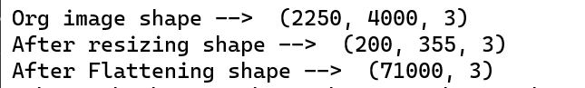

INPUT IMAGE:

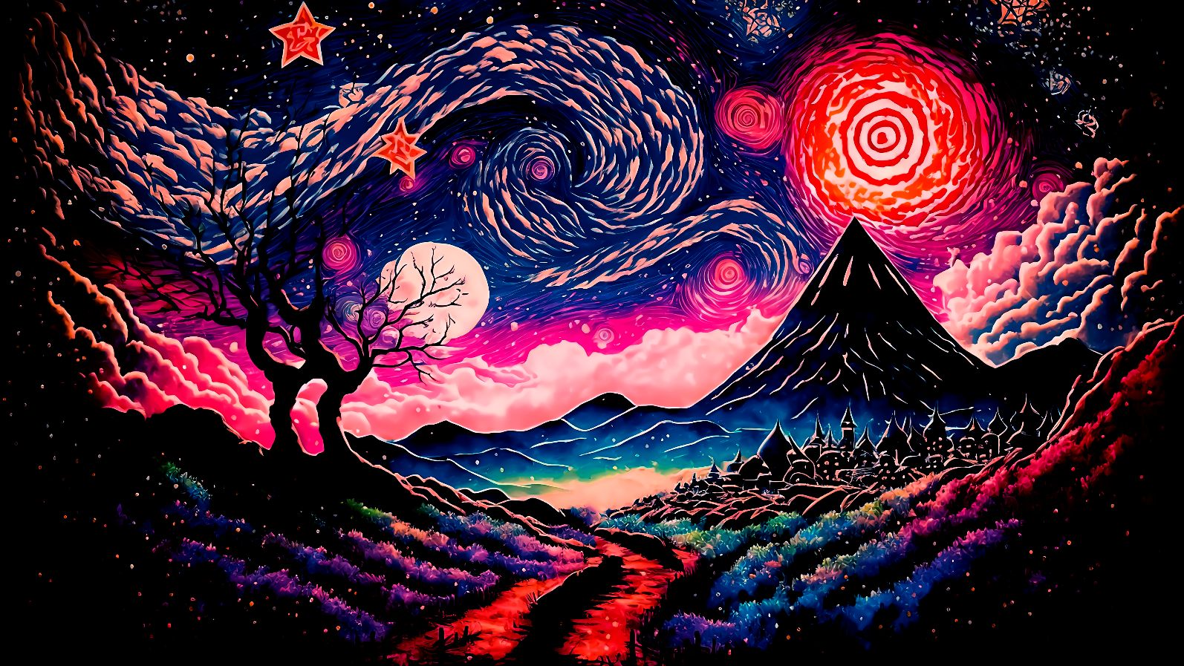

PROPORTIONS OF COLORS IN THE IMAGE:



COLOR FREQUENCY ANALYSIS:

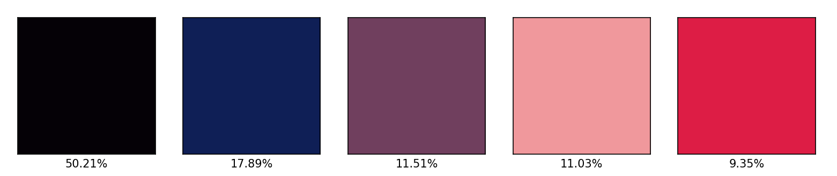

OUTPUT:

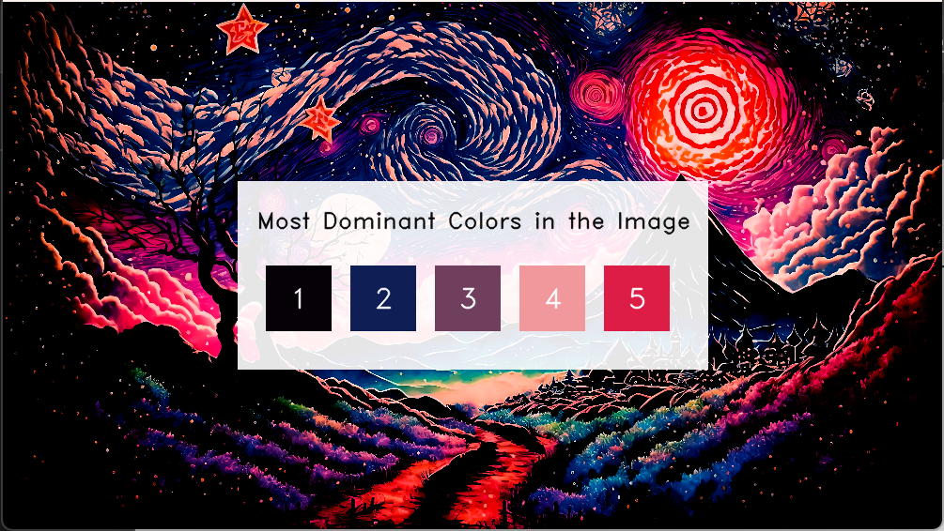

**CONCLUSION**

The project showcased the robustness of K-means clustering in identifying and visualizing dominant colors within images. Leveraging this algorithm, it accurately extracted and presented the top five prevalent hues, offering a comprehensive insight into the image's color palette. This method not only aids in aesthetic interpretation but also holds significance in various practical applications. The ability to efficiently recognize dominant colors serves as a foundation for image compression, content-based retrieval, and artistic rendering.

The project's success underscores the importance of unsupervised learning techniques like K-means clustering in image analysis. By providing a systematic approach to discerning dominant colors, it contributes to streamlined image interpretation and manipulation. Moreover, the visualization of dominant colors through proportional representation and modified image display offers intuitive insights into an image's visual composition.

This project's outcomes reveal the potential impact of K-means clustering in diverse fields reliant on visual data interpretation. Its efficacy in identifying prevalent colors not only enhances image understanding but also opens avenues for innovative applications, emphasizing the algorithm's relevance and versatility in modern image processing and analysis endeavors.

**REFERENCES**

1. <https://www.javatpoint.com/k-means-clustering-algorithm-in-machine-learning>
2. <https://towardsdatascience.com/understanding-k-means-clustering-in-machine-learning-6a6e67336aa1>
3. <https://pypi.org/project/scikit-learn/>
4. <https://www.youtube.com/watch?v=4b5d3muPQmA>